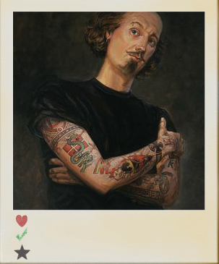**COMMEMORATIVE**

 FILM SESSION

**The Merchant Of Venice** Tuesday, 22nd March, 10.30

**Much Ado About Nothing**  Tuesday, 22nd March, 8.30

**ENGLISH**

**OVS**

**Shakespeare In Love**  Monday, 21st March, 12.45

1616-2016

400th Anniversary of William Shakespeare’s death