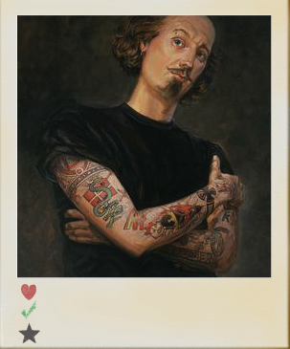**COMMEMORATIVE**

****FILM SESSION

**ENGLISH**

**OVS**

The Merchant Of Venice Tuesday, 22nd March, 10.30

1616-2016

400th Anniversary of William Shakespeare’s death

Much Ado About Nothing Tuesday, 22nd March, 8.30

Shakespeare In Love Monday, 21st March, 8.30