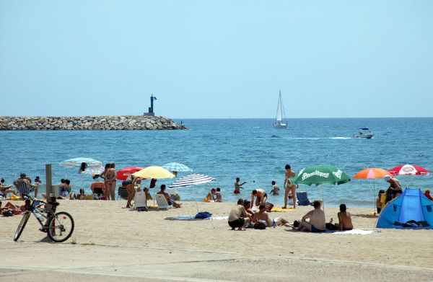

My favourite place is Cambrils’ beach, in Tarragona.

It is a sandy and beautiful beach, but in summer it’s very busy and crowded.

Near the beach, there is a port, it’s lively and pleasant, you can see the boats and later eat in a restaurant or have an ice cream.

Manuela Navarro 2 C